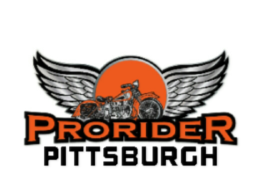









**We are certified police motorcycle instructors and motorcycle rodeo competitors. We will teach you to master the same skills and techniques used by motorcops across the country.**

**Sign up today! Classes fill up fast!**

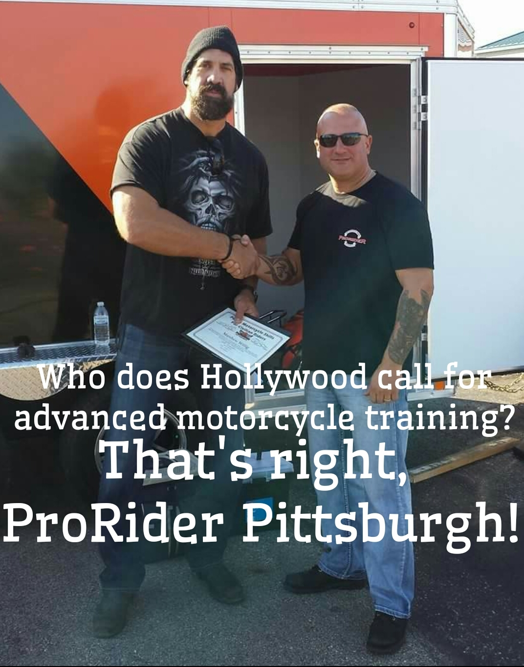

**Classes are conducted in a relaxed, low-stress environment by highly-qualified instructors. All classes are time in the saddle riding. No boring lectures in a classroom. Women’s classes and group discounts are available.**

**Precision and Control Course (4 hours)**

This is a challenging half-day class that will give riders an intimate knowledge of their bikes capabilities. Riders will learn simple techniques that will help them master their rides, and develop ultimate control over their bikes. This course will focus on slow speed and confined space maneuvers with real-life application.

**Advanced Rider Course (8 hours)**

This is a full day class for the rider that wants it all. The class will provide defensive riding, slow-speed control and confined space maneuvering skills. Learn and practice techniques that will polish your crash avoidance skills, reinforce proper emergency braking, swerving and rear-end collision avoidance. This course will teach you how to handle your bike with precision and ease, and enhance your overall road safety.

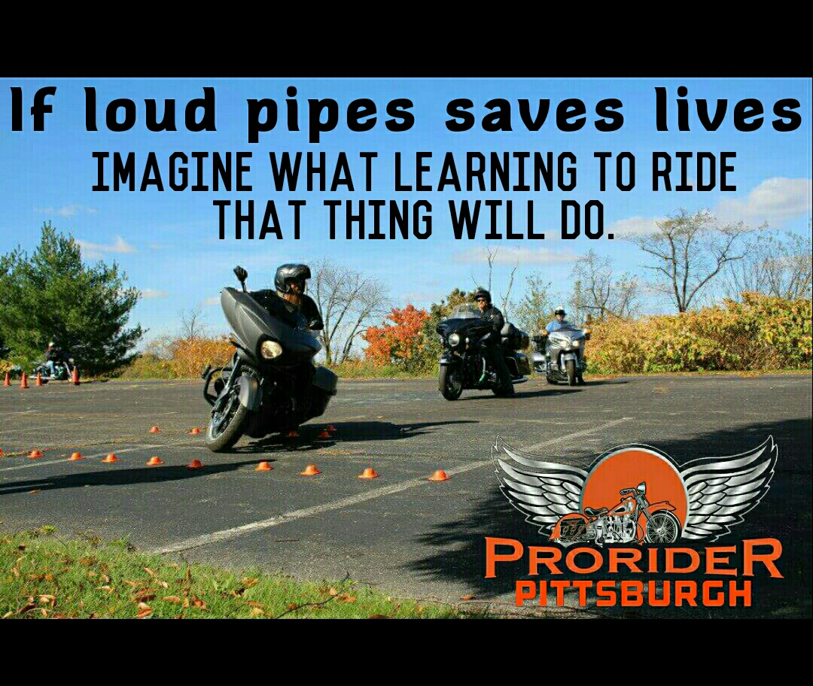

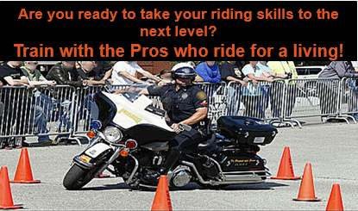

Advanced motorcycle skill courses include the same training exercises used by police motor officers and motorcycle rodeo competitors.

POLICE MOTORCYCLE SKILLS

FOR CIVILIAN RIDERS